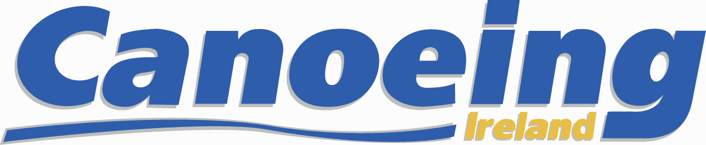

Training and Development Officer

We are seeking a dynamic and committed individual to develop paddlesports in Ireland in accordance with Canoeing Ireland’s Strategic Plan.

The Training and Development Officer will be a key member of a small team operating from Irish Sport HQ. We work with all stakeholders – clubs, disciplines, members, institutions - to increase and improve participation in paddlesports in Ireland. Key activities are:
- Training – administer the CI training and coaching schemes, working actively to promote CI’s award schemes through internal and external stakeholders, particularly clubs, providers and statutory agencies.
- Development – As a member-club centred organisation, strengthening the capacity of our clubs to grow the sport is a core function. The TDO will play a key role in this task, while also developing mutually advantageous relationships with external stakeholders.
- Training Centre – The CI Training Centre at Strawberry Beds on the River Liffey, is a valuable asset to the organisation. The TDO will oversee the management, development and financial sustainability of the centre.
The TDO will also carry out the day to day running of CI’s Training and Development Unit - answering members queries, processing panel applications, overseeing Coaching Ireland, QQI, EPP etc. deadlines and paperwork.
Applicants must have at a minimum:
- Third level education
- Sound understanding of the Quality and Qualifications Ireland (QQI) role in the quality assurance of CI training programmes and awards.
- Full, clean driving license, ideally a mini-bus driver’s license
- Garda Vetting Clearance
- Code of Ethics Certification
- Excellent inter-personal, communication, IT and report-writing skills
- Two recent, relevant referees.

Experience, skills and attributes that will support an application will include:
- A range of experience in canoeing disciplines and a range of sports.
- Experience in Youth Kayaking Programmes.
- Experience in management of an activity centre.
- Experience of working in a sports development environment.
- Canoeing Ireland Level 3 Instructorship or Equivalent
- Experience of working with sports clubs, community groups, and young people in a community setting
- Experience in planning, co-ordinating and delivering sustainable sporting & recreational programmes
- Recognised qualification at degree level or equivalent in sports development, leisure management or similar
- Excellent communication & organisational skills
- A good understanding of project-based programme delivery with measurable outcomes
- A good understanding of and experience in project evaluation
- Be motivated by and committed to sports development and increasing opportunities for participation
- Be self-motivated and able to work independently to meet or exceed goals
- Flexible approach to working evenings and weekends.

The position is being offered on a three year, nine-month fixed term subject to a successful probationary period of 9 months and annual performance appraisal. Salary will be commensurate with experience subject to annual satisfactory performance appraisal. Continuity of this role will be subject to funding availability. The TDO will report to the CEO of Canoeing Ireland. Appropriate training and personal development opportunities will be provided. Work base will be the National Sports Campus, Blanchardstown, Dublin 15. Working hours will be 39hrs per week with occasional evening and weekend attendance required for which time-in-lieu will be offered. Annual leave of 22 days plus public holidays.

Applicants should send a Cover Letter, CV and any supporting documentation in pdf format by email to jobs@canoe.ie. The closing date for receipt of applications is November 17th 2017.

