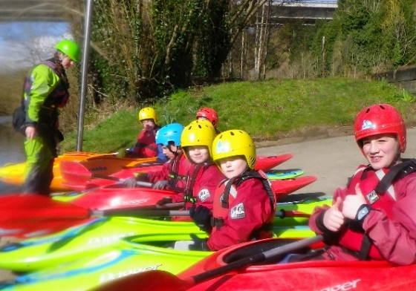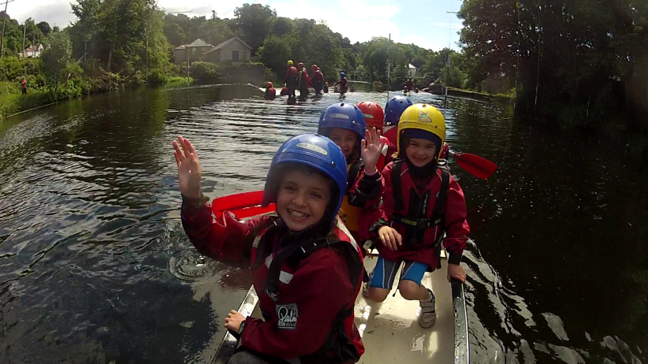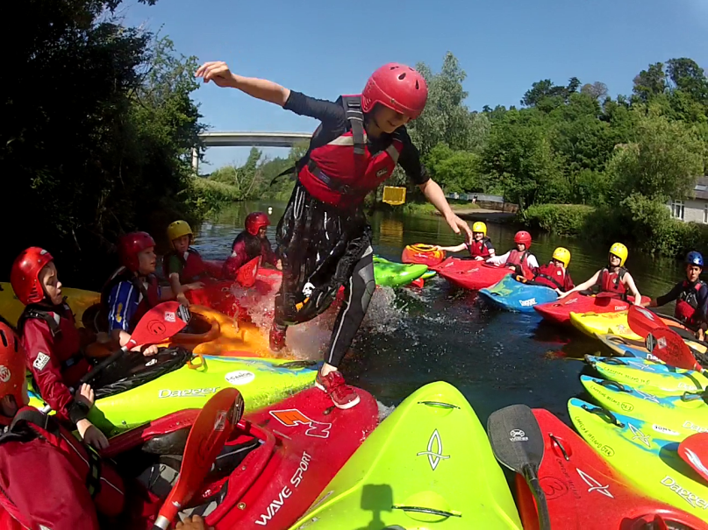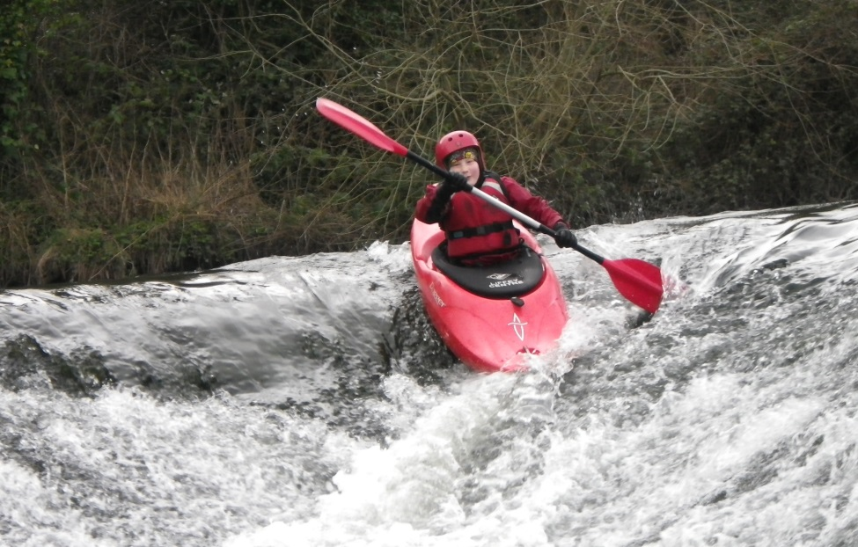

We have **5 Camps** which start **Every Monday**

**Week 1:** Monday, 3rd July – Thursday 6th July

**Week 2**: Monday 10th July – Thursday 13th July

**Week 3:** Monday 17th July – Thursday 20th July

**Week 4:** Monday 24th July – Thursday 27th July

**Week 5:** Monday 21st Aug – Thursday 24th July

**Junior Camp:** 8 – 12yrs, €80 per child 10am until 1pm

**Senior Camp:** 13 –16yrs, €120 per child 10am until 3pm

**Advanced Camp:** 12 – 17yrs, € 140 per child 10am until 4pm

Visit [www.canoe.ie](http://www.canoe.ie) for information

**Make Friends – Water Confidence**

**The Camp will operate from our Training Centre on the**

**Strawberry Beds, Lucan**

**For more information or to book, e-mail training@canoe.ie**

**Have Fun – New Sport**

**Summer Camp**

**2017**

**2012017**