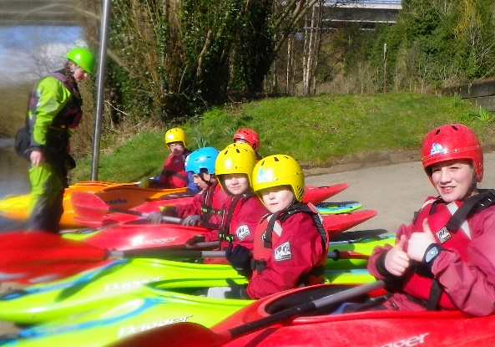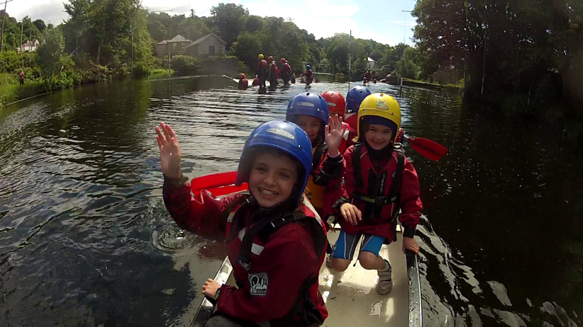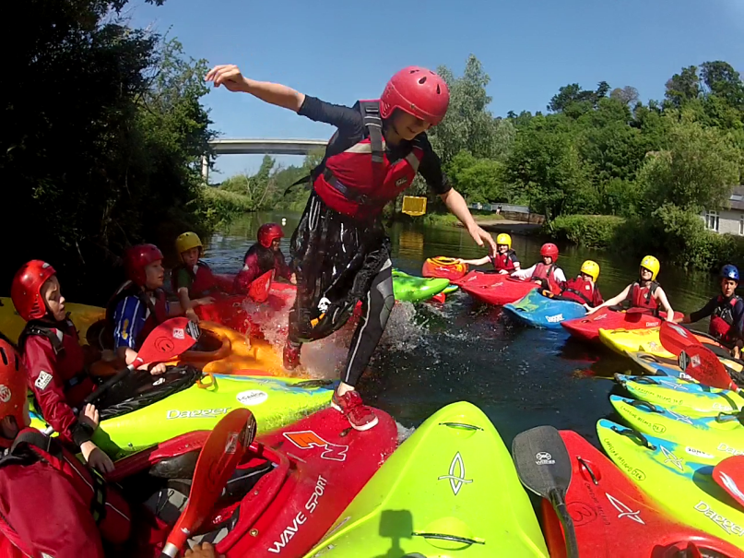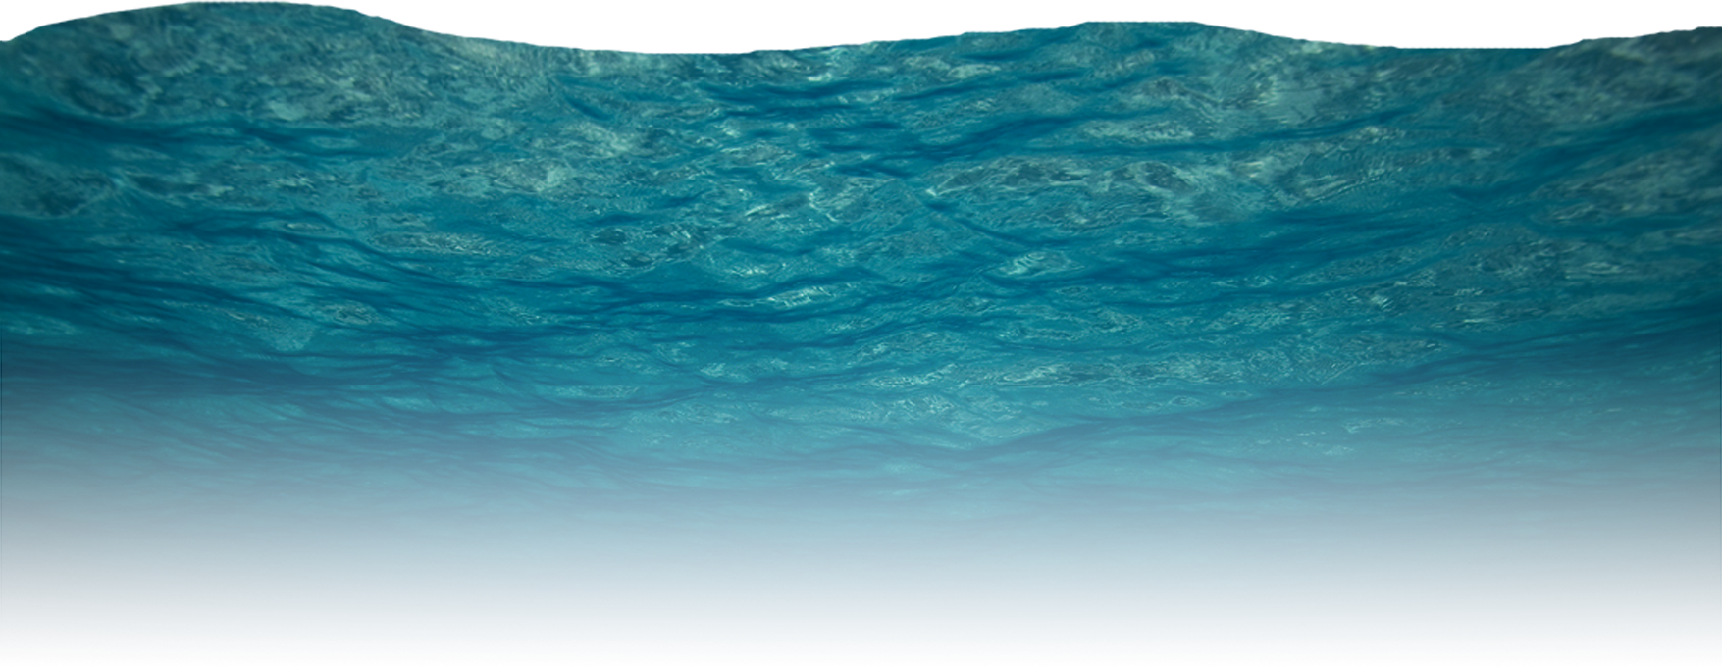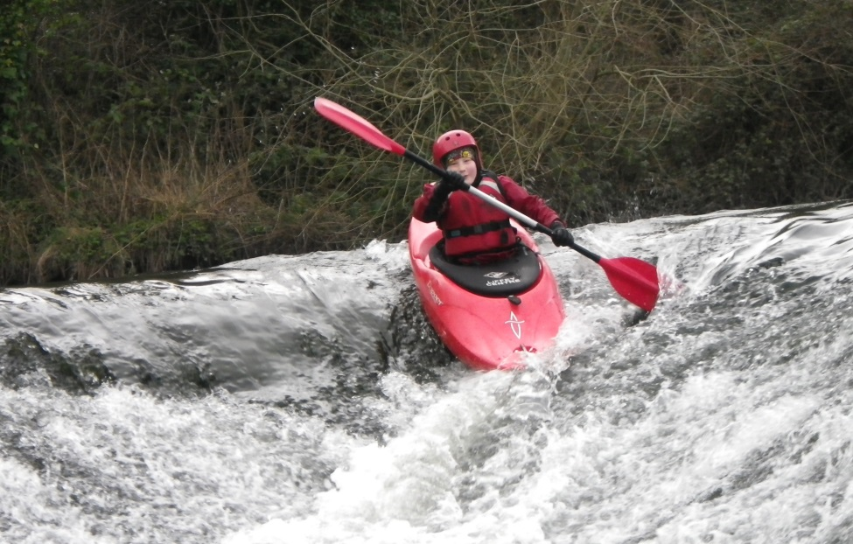

**Summer Camp**

**2017**

**2012017**

**Make Friends – Water Confidence**

**Have Fun – New Sport**

We have **8 Camps** which start **Every Monday**, from

**First Week:** Monday, 3rd July – Friday 7th July

to

**Last week:** Monday, 21st – Friday 25th August

**Junior Paddlers:** 8 – 12yrs old, €99 per child

Mornings 10am until 1pm

**Senior Paddlers:** 13 – 16yrs old, €145 per child

Daily 10am until 3pm

Visit [www.canoe.ie](http://www.canoe.ie) for information

**The Camp will operate from our Training Centre on the**

**Strawberry Beds, Lucan**

**For more information or to book, e-mail paddlesessions@canoe.ie**

**Or call: 01-6251105**