Inny Ranking Slalom
10 April 2016
Division 1 , Division 2, Team Race, Open Race
Open Race competitors will run the same course as Divisions 1/2 but will not need to negotiate some of the more difficult Gates. This Race is suitable for experienced White Water paddlers and slalom paddlers who are transitioning from Division 3.
Recently promoted Division 2 paddlers looking to build experience may enter both the Open Class and Division 2.
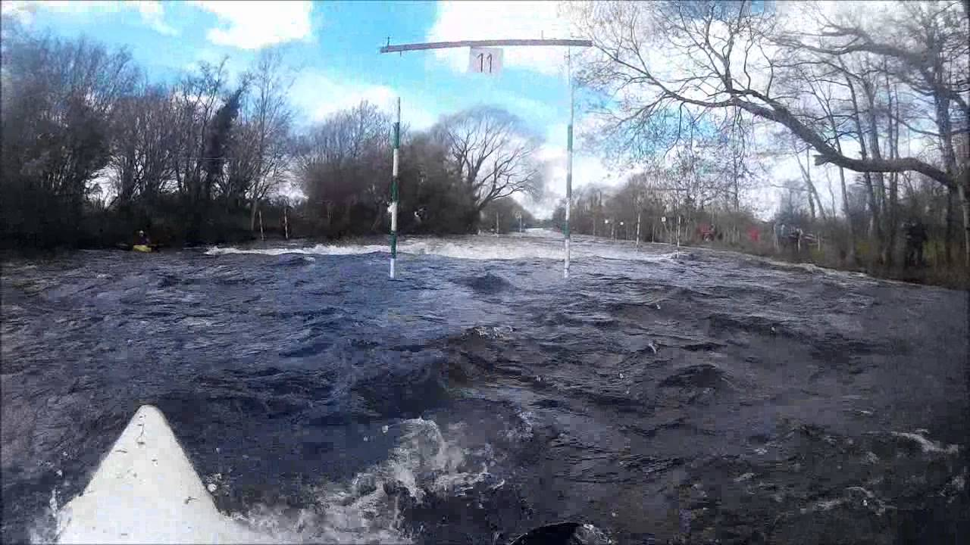
Location: Ballymahon, Co. Longford. Entries and Check-in for Pre-Registered Paddlers up to 10 am at Newcastle Woods Car Park.
Entry Fee: €10 Senior / €5 Junior
Enquiries to : Innykayakers@gmail.com

