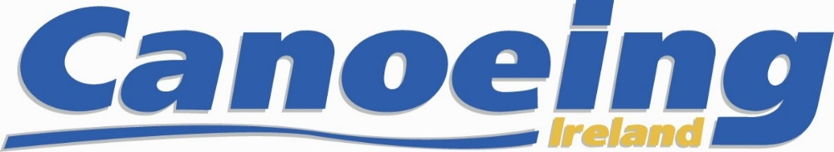

Application Form for Junior Athletes

2019 Canoe Slalom Selection Races
Sluice Weir, Lucan March 23 & 24th 2019

Applicants must submit Selection Application Form
on or before the 28th of February 2019

Section 1, Junior Athlete Details
Name

Date of Birth
Gender
Address
Parents Email Address
Parents Mobile Phone No
Canoeing Irl Mbr No.
Emergency Contact
Emergency Phone No

Section 2, Indicate the Classes and Categories
in which Selection is sought
Mens / Womens | Category K1 / C1 | Junior

Section 3, Athlete Acknowledgement and Signature
I hereby acknowledge that:

- I have read, understand and agree to abide by the Terms of Selection as detailed in the Irish Canoe Slalom Selection Policy for 2019.

- I will be specifically bound in the case of a dispute, complaint or appeal to abide by the Canoeing Ireland Appeals and Complaints procedures. In the event that, for any technical reason, a dispute, complaint or appeal cannot be dealt with by the Canoeing Ireland Appeals and Complaints procedures, I hereby agree that any such dispute, complaint or appeal may be referred to JSI for final and binding mediation and/or arbitration.

3. If I have any medical condition that inhibits my ability to canoe safely I will notify
The Hp Director by email to performance @canoe.ie

4. I will abide by the Rules of Sport Ireland, Canoeing Ireland Anti Doping and WADA

*_________________________ * __________________________________ ____________
Competitors Signature Print Competitors name Date

*_________________________ * __________________________________ ____________
Parent signature Print Parents name Date

Please Note: Junior athlete, together with his or her Parent / Guardian, must sign a hard copy of the selection application form to be then emailed and posted to Canoeing Ireland.

All correspondence is made with the Parents / Guardians when dealing with our Junior Athletes.

Application Process, fees and payment information is on the next page

Application Process, Fees and Payment
Applicants must submit Selection Application Form
on or before the 28th of February 2019
- Complete the Application form, save form and pdf and email to performance@canoe.ie and Post hard copy with Signatures to: HP Director, Canoeing Ireland, Sport HQ, National Sports Campus, Dublin 15. Ensure the following;

  - A completed Selection Application Form is completely filled in and has been signed by the applicant and Parent / Guardian

  - A copy of the athlete’s Irish passport or of a UK passport that shows the athlete’s place of birth to be Northern Ireland.

2. Race Entry fee

1) The Selection Race and registration fee of € 30.00 for Junior Selection
This includes and is a part of the Irish Open Championship 2019
This fee must be paid by 28th of February to secure your place

Bank details below for lodgement to the slalom committee’s bank account. If you wish to lodge the fees, please do so by a counter transaction at any Ulster Bank branch or by electronic transfer (SEPA payment) using the following details:

Account Name | Irish Canoe Union (Canoeing Ireland)
Bank | Ulster Bank
Bank Branch | Main Street, Dundrum
Sort | 98 50 55
Account Number | 15193796
BIC | ULSBIE2D
IBAN | IE69 ULSB 985055 15193796
Reference | Please enter the name of the athlete

