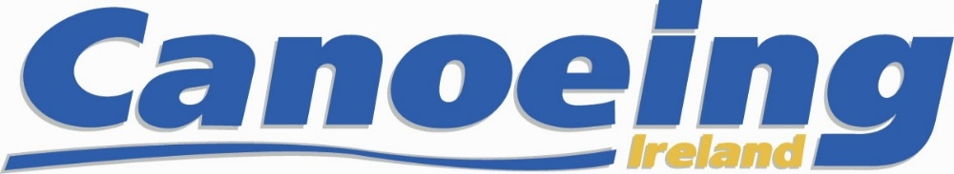

Application Form for U23 and Senior Athletes

2020 Canoe Slalom Selection Races
Lee Valley October 5 & 6th 2019, London England

Applicants must submit Selection Application Form
on or before the 9th of September 2019

Section 1, Athlete Details
Name

Date of Birth
Gender
Address
Email Address
Mobile Phone No
Canoeing Irl Mbr No.
Emergency Contact
Emergency Phone No

Section 2, Indicate the Classes and Categories
in which Selection is sought
Mens / Womens | Cat K1 / C1/ XCS | Sen/U23 (if you are seeking both use two rows- XCS other)

Section 3, Athlete Acknowledgement and Signature
I hereby acknowledge that:

- I have read, understand and agree to abide by the Terms of Selection as detailed in the 2020 Irish Canoe Slalom Selection Policy.

- I will be specifically bound in the case of a dispute, complaint or appeal to abide by the Canoeing Ireland Appeals and Complaints procedures. In the event that, for any technical reason, a dispute, complaint or appeal cannot be dealt with by the Canoeing Ireland Appeals and Complaints procedures, I hereby agree that any such dispute, complaint or appeal may be referred to JSI for final and binding mediation and/or arbitration.

3. If I have any medical condition that inhibits my ability to canoe safely I will notify
The Hp Director by email to performance @canoe.ie

4. I will abide by the Rules of Sport Ireland, Canoeing Ireland; Anti Doping and WADA

*______________________ * ___________________________ ______________________
Competitors Signature Print Competitors name Date

Please see the following page for finishing the application process

Application Process, Fees and Payment
Applicants must submit Selection Application Form
on or before the 9th of September 2019
- Complete the Application form, Print, Save form and pdf and email to performance@canoe.ie and please cc Slalomsecretary@canoe.ie

  - A completed Selection Application Form is completely filled in and has been signed by the applicant.

  - A copy of the athlete’s Irish passport or of a UK passport that shows the athlete’s place of birth to be Northern Ireland.

2. There are 2 required fees to be paid. Only Registration fee due NOW

1) There is a registration fee of € 15.00 for U23 & Senior Selection
Application, this includes entry for Irish Open Championship 2020
This fee must be paid by 11th of September 2019 to secure your place

2) Race Entry Fee’s for Selection at Lee Valley is expected to be
approximately £40 for Adults, We will confirm when payable

Bank details below for lodgement to the slalom committee’s bank account. If you wish to lodge the fees, please do so by a counter transaction at any Ulster Bank branch or by electronic transfer (SEPA payment) using the following details:

Account Name | Irish Canoe Union (Canoeing Ireland)
Bank | Ulster Bank
Bank Branch | Main Street, Dundrum
Sort | 98 50 55
Account Number | 15193796
BIC | ULSBIE2D
IBAN | IE69 ULSB 985055 15193796
Reference | Please enter the name of the athlete

