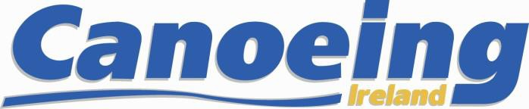

Child Safeguarding Statement
Canoeing Ireland provides various sporting activities and opportunities for young people through participation in clubs, regional/provincial events, at our Training Centre and through our national teams.
Canoeing Ireland is committed to safeguarding children. By working under the guidance of our Safeguarding Policies our volunteers and staff, working with our young people throughout the organisation, seek to create a safe environment for young people to grow and develop.
Canoeing Ireland’s written Risk Assessment document indicates the areas of potential risk of harm, the likelihood of the risk occurring, and gives the required policy, guidance or process documents require to alleviate these risks. The list of risks identified are contained in the following categories: Club and Coaching Practices; Complaints & Discipline; Reporting Procedures; Use of Facilities; Recruitment; Communications; and General Risk of Harm.

A review of our Risk Assessment was undertaken in 2022. Canoeing Ireland Risk Assessment

Our Child Safeguarding Statement has been developed in line with requirements under the Children First Act 2015, the National Guidance for the Protection and Welfare of Children and Tusla’s Child Safeguarding Guide for Policy, Procedure and Practice. In addition to our Risk Assessment document described above, there are further procedures that support our commitment to safeguarding children while they are availing of our activities.
Canoeing Ireland has the following procedures in place as part of our Safeguarding Policies:
- Procedures for the management of allegations of abuse or misconduct by staff or volunteers against a child availing of our activities
- Procedures for the safe recruitment of staff and volunteers to work with children in our activities
- Procedures for access to child safeguarding training and information, including the identification of the occurrence of harm
- Procedure for reporting of child protection or welfare concerns to Statutory Authorities The Mandated/Relevant Person for Canoeing Ireland is Moira Aston.
The National Children’s Officers are Heather Wilson & John Daly safeguarding@canoe.ie
We recognise that implementation is an ongoing process. Canoeing Ireland is committed to the implementation of this Child Safeguarding Statement and the procedures that support our commitment to keep children safe from harm while availing of our activities.
This Child Safeguarding Statement will be reviewed on February 1st 2023
Signed: 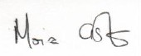 Date: Feb 1st 2022
(On behalf of Canoeing Ireland)
Name: Moira Aston, CEO Phone no: 0879752242

