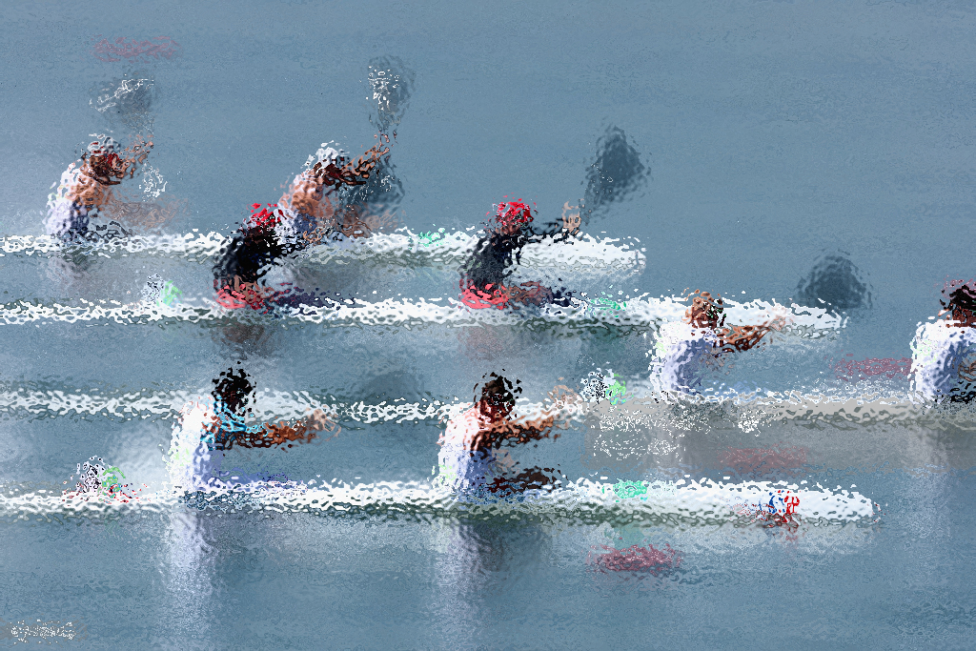
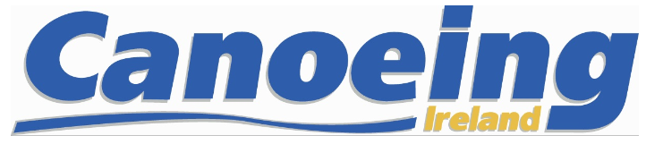
Canoe Sprint
Selection Policy 2023
Senior

Contents

0.List of abbreviations (in alphabetical order) 2
1 Introduction 3
1.0 Purpose 3
1.1 The European Games 3
2. Athlete Eligibility 3
Oversight 4
4. 2023 Irish Canoe Sprint Team Selection Policy Terms & Conditions 4
5. The Selection Process 5
5.1 Pre-selection 5
5.2 Performance Selection 5
5.3 Senior performance criteria 5
5.4 Performance criteria 5000m 5
6. Selection to the World Championships 6
8. Determining the results of the selection process 6
9. Extenuating Circumstances 6
10. The Selection Panel 7
10.1 Conflicts of Interest Any member of the SP shall declare any conflicts or potential conflicts of interest and shall refrain from participation in the discussion of and any vote in respect of any selection matter in which they have a material conflict of interest. 7
11. Funding Process 2023 7
11.1 Payment deadlines and costs 8
12. Ongoing Assessment 9
13. Selection Appeals Process 9
14. Appendix A – Key competition dates 10
End of Document 10

0.List of abbreviations (in alphabetical order)

CEO | Chief Executive Officer
CI | Canoeing Ireland
CSIC | Canoe Sprint Ireland Committee
DNF | Did not finish
ECA | European Canoe Association
HPU | High Performance Unit
ICF | International Canoe Federation
ICSC | Irish Canoe Slalom Committee
NGB | National Governing Body
ODR | Olympic Discipline Representative
PD | Performance Director
SP | Selection Panel

1 Introduction

1.0 Purpose
The Purpose of this selection policy is to outline the processes which will lead to the selection of athletes to represent Ireland at senior international canoe sprint competitions in 2023. The selection policy is designed to allow athletes to maximise preparations and performances at the World Championships, and World Cups in 2023 through a clear and objective selection process. For clarity, the European Championships will run as the European Games in 2023.

The European Games
The 2023 European Games will be run under the auspices of the European Olympic Committee. Selection to the European Games is covered under a different process.
Athletes who have achieved criteria in 2022 and who have been nominated to the Olympic Federation of Ireland as per the OFI nomination policy:
Jenny Egan
The Olympic Federation of Ireland are responsible for all selection decisions to Team Ireland.
  - Canoeing Ireland Strategic Performance Objectives – 2028
Canoeing Ireland is committed to the support and development of our current and future team of performance sprint athletes. We intend, within the next two Olympic cycles, to grow our capacity to be competitive in all classes (K1W, K1M, C1W, C1M and crew boats) and in all age categories (Senior, U23, U18) at the highest level of international competition (Olympic Games, World Championships, European Championships) through a comprehensive performance programme.

2. Athlete Eligibility
To be eligible to compete for Ireland, athletes must meet and maintain for the duration of the 2023 competition season the following athlete eligibility criteria:
- Be a current registered member of Canoeing Ireland who is eligible to represent Ireland at ICF canoe sprint events in accordance with ICF rules and have no outstanding debt to Canoeing Ireland or any of its technical committees.
- Hold or be eligible to hold an Irish passport.
- Is not the subject of a doping violation investigation or suspension.
- Is fit to perform to the best of their ability.
- Has signed the athlete agreement found at the end of this 2023 selection policy and the subsequent athlete contract.
- Has paid the required deposit by the deadline provided (see 11.1).

3. The Key Stakeholders and process outline
The Performance Director (PD) is responsible for the development of selection policies.

Consultation
Athletes will be consulted, and their input sought on the first and final draft of the selection policy prior to publishing.

Oversight
The CEO, HPU and the CI Board will all have oversight of the Selection Policy for 2023. The Board will have ultimate authority in approving the Selection Policy for publication

4. 2023 Irish Canoe Sprint Team Selection Policy Terms & Conditions
4.0 Previous selection policies or criteria can have no bearing on this 2023 selection policy.
4.1 No athlete can be considered for selection for the 2023 Irish canoe sprint team if they do not meet and maintain the athlete eligibility criteria set out in section 2 above.
4.2 An athlete who for any reason, fails to maintain eligibility may be removed from the 2023 Irish canoe sprint team. Eligibility issues will be communicated in the first instance by the PD. Any athlete who has been removed from the 2023 Irish canoe sprint team will be replaced by the next ranked athlete.
4.3 Athletes for all major international events must comply with International Canoe Federation (ICF) Rules and European Canoe Association (ECA) Rules. Entry to ICF and ECA events is restricted to members of the National Governing Bodies affiliated to the ICF and the ECA. In Ireland, the affiliated National Governing Body is Canoeing Ireland.
4.4 The selection of an athlete for inclusion on the 2023 Irish canoe sprint team shall be confirmed to that athlete in writing by the PD within 7 days of the official team being agreed on and all appeals, if any, have concluded.
4.5 If an athlete's selection is made subject to that athlete meeting further conditions, such further conditions will be communicated as soon as possible to the athlete.
4.6 All entries of Irish canoe sprint athletes to canoe sprint events must be made through the Canoeing Ireland office following the selection of athletes pursuant to the 2023 selection policy.
4.7 Proposals to amend this 2023 selection policy may be put forward if amendments are necessary and such amendments are determined to be in the best interest of athletes and Canoeing Ireland. Proposals to amend this 2023 policy will be submitted to the PD. All proposed amendments must be ratified by the Canoeing Ireland CEO in the first instance and approved the HPU and CI Board. All final amendments will be clearly identified and will be binding on all athletes.
4.8 Canoeing Ireland reserves the right to deselect an athlete who has been found guilty of a disciplinary offence under Canoeing Ireland /ICF rules. This includes doping offences.
4.9 Athletes must have the required deposit paid by the stated deadline. Failure to adhere to this deadline will render the athlete ineligible.

5. The Selection Process

5.1 Pre-selection
An athlete who has won medals in the 2022 season (senior WC’s, European Championships, World Championships) is eligible for pre-selection in 2023. Pre-selection will only apply to the distance that the athlete medaled in and will pre-select the athlete for World Cup 1 and 2 only.

Pre-selected athletes in 2023:
Jenny Egan | K1 5000m

5.2 Performance Selection
Athletes may achieve performance selection at the April Nottingham Regatta. At this event athletes will be ranked in accordance with their finished position within the criteria outlined below in Table 1. Local regatta rules will apply. Enquiries and protests must be submitted to the race organisers. Decisions made and upheld by the race organisers will be final.

5.3 Senior performance criteria

Table 1 – Senior performance criteria

Category | Performance Criteria – all distances
K1 Men | Top 6 Finish Men’s A
K1 Women | Top 6 Finish Women’s A
K2 Men | Top 3 Finish Men’s A
K2 Women | Top 3 Finish Women’s A
C1 Men | Top 6 Finish Men’s A
C1 Women | Top 6 Finish Women’s A
K4 Men | Top 3 Finish Men’s A
K4 Women | Top 3 Finish Women’s A
Developmental crew boats may be added to international events post selection.

5.4 Performance criteria 5000m
The selection event for 5,000m will involve one event and will run as part of the 5K Series (Appendix A – Key Competition Dates). The times shown in the table below will be used as a guide to assist in the selection of athletes for 5000m events. Athletes who finish 1st and 2nd at this event and who meet the expected times will be eligible for selection for World Cup 1 and World Cup 2. In the women’s 5000m the fastest athlete not already selected will be eligible for selection to WC 1 and 2 (see 5.1).
Event | Expected 5km Standard
Senior Men | 22:39
Senior Women | 25:48

6. Selection to the World Championships
At the senior World Championships only one athlete per National Federation can race in any one distance per event. Therefore, the athlete/s to attend the World Championships must be the fastest of the 2 Irish boats at World Cup 1 and World Cup 2 (by placing).
If athletes are tied after this process, ranking positions obtained from the Nottingham selection race will decide the winner. The successful athlete/s will be selected the World championships only.

8. Determining the results of the selection process
On completion of the selection process the following actions will occur:
- PD will create a ranking list of results
- The selection panel is convened
- The final ranking list for the participant athletes is presented to the SP by PD
- The SP review the results and select the team (provisional subject to appeals)
- All participants are informed of the results of the selection meeting
- Any non-selected athletes are permitted to appeal within the defined process
- If appeals are received, they are dealt with through the normal appeals process
- If no appeals are received within the time period allowed the team as selected is confirmed as final.
- The PD will write to all successful athletes and inform them of their selection (provisional pending the signing of the athlete contract).

9. Extenuating Circumstances
Extenuating circumstances are serious, unforeseen circumstances beyond an athlete’s control (i.e., illness, injury, family bereavement, etc) which genuinely prevent them from competing at the selection event.
If an athlete misses the selection event due to extenuating circumstances and that athlete has recognised international experience and is deemed to be of a suitable performance standard, the following protocols may be activated.
- The slowest ranked boat in the class/distance being contested may be required to race a head-to-head with the athlete(s) who could not make the selection event. This head-to-head will take place at Lough Rynn or another suitable site that allows for head-to-head racing within 10 days of the selection event. The winner of this head-to-head will be ranked 2nd boat for WC1 and WC2.
- If the class/distance remains uncontested (there is only one athlete selected) an athlete may be selected as the 2nd boat by discretion if that athlete has recognised international experience and deemed to be of a suitable performance standard. If more than 1 athlete has applied under extenuating circumstances a head to head race off will take place.
NOTE: In the case of injury or illness, it is the athletes’ responsibility to submit a letter from their medical practitioner (GP) a minimum of 2 days prior to the scheduled event. In all cases submissions shall be made to the PD. DNF’s will not be eligible to apply for selection under extenuating circumstance however, circumstances where verifiable and obvious equipment failure occur during the selection event, these will be dealt with on a case-by-case basis.

10. The Selection Panel
The Selection Panel (SP) will, after review of the results of the selection process, ensure that all proposed athletes meet the eligibility criteria prior to official selection confirmation. The SP can only consider an athlete who meets and maintains the athlete eligibility criteria set out in section 2, and therefore shall have the final determination, acting reasonably, as to whether an athlete meets the eligibility criteria.
The SP will be convened and chaired by a member of the board of Canoeing Ireland. The selection panel will be ratified by the Canoeing Ireland CEO. The SP will consist of the following 3 members:
- Member appointed by the Board of Canoeing Ireland with the relevant expertise
- The Performance Director
- One independent member*
*Independent member can be from another NGB or canoeing discipline with relevant experience.

10.1 Conflicts of Interest
Any member of the SP shall declare any conflicts or potential conflicts of interest and shall refrain from participation in the discussion of and any vote in respect of any selection matter in which they have a material conflict of interest.
A conflict of interest might occur when, for example:
- A Selection Panel member is a club coach to a particular athlete vying for selection.
- A Selection Panel member is closely aligned to or is a member of a club for which an athlete vying for selection is also a member of.
- A Selection Panel member is a family member or close friend of an athlete vying for selection.
- Or any circumstance where a Selection Panel member has a personal relationship with an athlete or athletes vying for selection which could influence his or her decision or stands to gain in any way from the outcome of a selection decision.

11. Funding Process 2023
For 2023, retrospective funding process will be in place. A tiered system has been developed which aims to support athletes who have achieved a specified result at World Cups and World Championships.
Tier 1
Athletes who finish top 5 in an A-final at World Cup 1 and 2 and World Championships will receive 100% funding (items covered are listed below). This is applicable to the relevant Olympic distances/categories only (200m, 500m, 1000m).
Funding will be allocated retrospectively and will cover:
- Accommodation
Official Transfers
Accreditation
Boat Hire
*Flights and carriage of paddles will not be funded
Tier 2
Athletes who finish 6-9 in an A Final or 1-4 in a B Final at World Cup 1, World Cup 2, European and World Championships will achieve 50% funding. This is applicable to the relevant Olympic distances/categories only (200m, 500m, 1000m).
Funding will be allocated retrospectively and will cover:
- Accommodation
Official Transfers
Accreditation
Boat Hire
*Flights and carriage of paddles will not be funded
Tier 3
25% funding will be allocated retrospectively for athletes who finish 5-9 in a B Final and progress no further. This is applicable to the relevant Olympic distances/categories only (200m, 500m, 1000m).
As above, funding will cover:
- Accommodation
Official Transfers
Accreditation
Boat Hire
*Flights and carriage of paddles will not be funded
Athletes who do not meet the specified results attached to Tier 1, Tier 2 or Tier 3 will receive no funding.

11.1 Payment deadlines and costs

To conclude the selection process and in line with eligibility criteria, athletes must have all competition fees paid four weeks prior to each competition. Failure to meet this payment deadline, see Table 1, will result in the athlete becoming ineligible for selection. All payment details and information will be dealt with in the first instance by the International Team Coordinator.

Table 2. Payment deadline dates
Event | Payment Deadline
World Cup 1 | April 11th
World Cup 2 | April 26th
World Championships | July 23rd

For guidance, an approximate breakdown of costs is supplied below in Table 2. The cost includes airport transfers, boat hire, accreditation, and accommodation. Athletes who wish to stay outside of the designated ICF accommodation can do so but must organise and book this accommodation themselves and organise transfers separately, regardless all payments must be made through the NGB, and all deadlines must be respected.
Table 3. Approximate costs
Event | Approx. Cost
World Cup 1 | €890
World Cup 2 | €890
World Championships | €1450

12. Ongoing Assessment

It is important that athletes understand that performance will be reviewed on an ongoing basis throughout the season. For the 2023 season, an athlete may be de-selected if sufficient evidence is available that the athlete is in breach of the Athlete's Code of Conduct, the Terms of Selection including eligibility, or the Athlete's Contract. The PD will engage with any athlete who is found to be in breach of any of the above.

13. Selection Appeals Process

The Canoeing Ireland Athlete Appeals Process can be found on the Canoeing Ireland website link: https://www.canoe.ie/governance-documents/

14. Appendix A – Key competition dates

Date | Events | Location
4th March | Canoeing Ireland 5k Series- selection for 5k | Salmon Leap CC
15th/16th April | Senior selection/British Sprint National Regatta | Nottingham
11th/14th May | ICF Sprint World Cup 1 | Szeged, Hungary
26th/28th May | ICF Sprint World Cup 2 | Poznan, Poland
23rd/27th August | ICF Canoe Sprint World Championships | Duisburg, Germany
30th August-1st September | ICF Canoe Sprint World Cup 3 | Paris
End of Document

