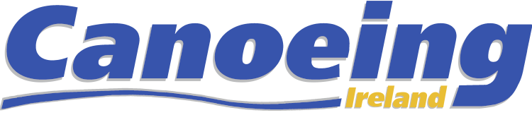

OFFICIAL CANOEING IRELAND NOMINATION FORM

Nomination |  | Registered Canoeing Ireland member
Position
Member Nominated
Nominating Person
Seconding Person

Relevant Experience and Qualifications of the Candidate:

All Nominations / Motions / queries should be notified to the relevant Committee no later than 14 days prior to the Annual Meeting by email to support@canoe.ie

Nominating persons and nominees should familiarise themselves with Canoeing Ireland Rules which are available here: RULES

